**Clark Atlanta IncludED Book Bundle**

**CAU SCHOLARS**

**Helpful Hints You Need to Know!**

**• Textbooks will be available for pick up starting on**

**August 20th, 2025**

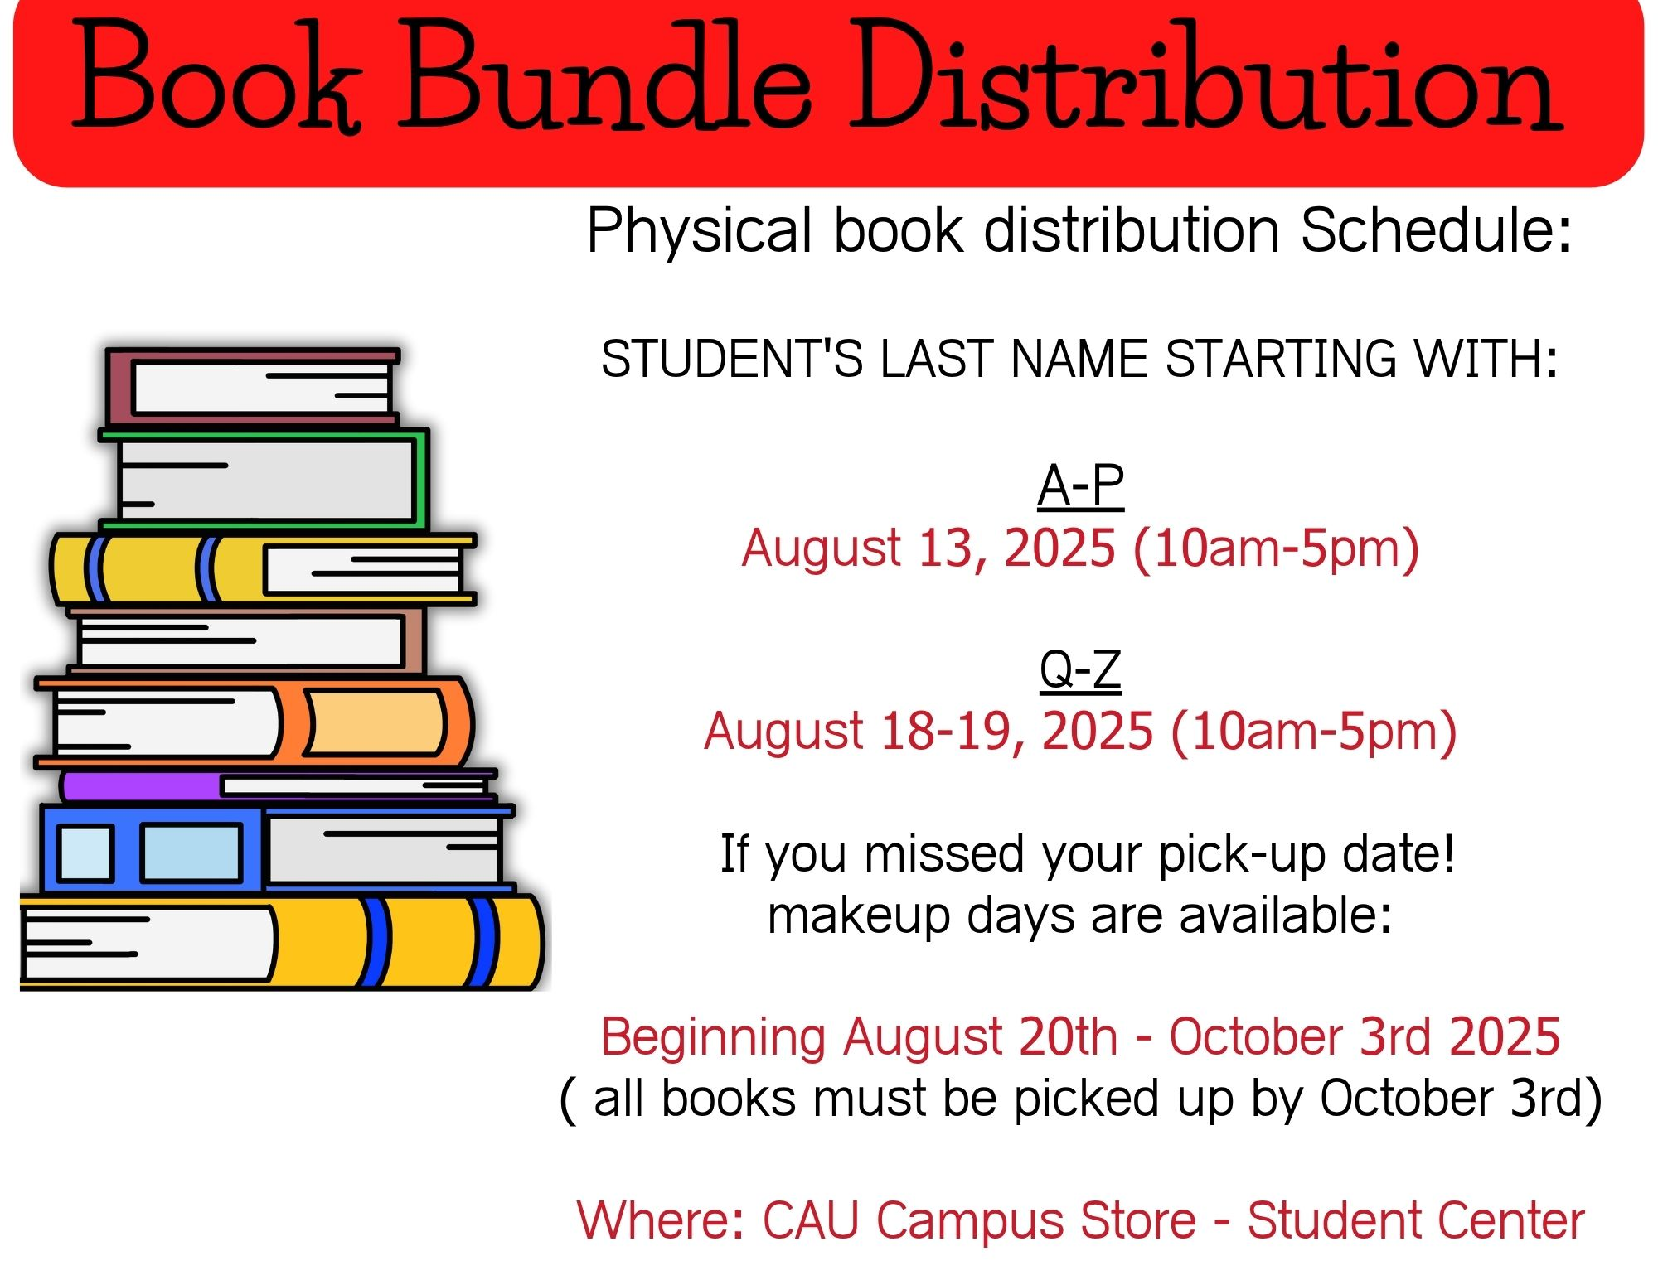



**• Be sure to check your CAU student email.**

**• All Book Orders are CONFIRMED.**

**• If you drop a class, please return the textbook ASAP. Digital materials will return automatically.**