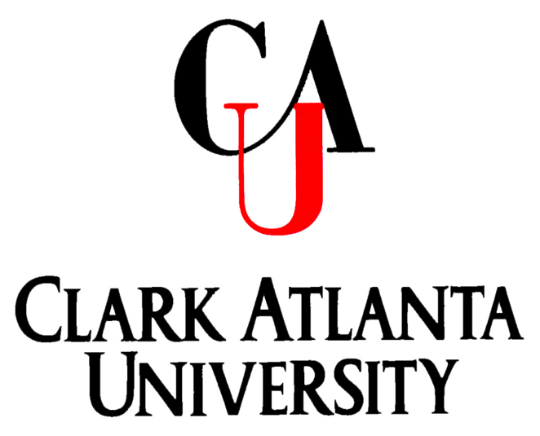

School of Education
Department of Counselor Education

***

CLINICAL MENTAL HEALTH COUNSELING & SCHOOL COUNSELING

MASTER OF ARTS

Mission Statement

The mission of the Department of Counselor Education is to prepare candidates to assume roles of leadership and service in society as Licensed Professional Counselors and/or certified School Counselors in accordance with the standards established by the Georgia Board of Professional Counselors, Social Workers, and Marriage & Family Therapists, the Council for the Accreditation of Counseling and Related Educational Program (CACREP), the Georgia Professional Standards Commission (PSC) and the Council for the Accreditation of Educator Preparation (CAEP).

Vision Statement

The vision of the Department of Counselor Education is to prepare a diverse pool of candidates who are knowledgeable, critical thinkers, and ethical change agents, who promote a more just society. Graduates are prepared to counsel and foster change through counseling in collaboration with schools and community stakeholders.

PROGRAM OBJECTIVES
- Introduce theory and concepts to human behavior, human service systems, and problems in human behavior at all developmental levels.

- Prepare candidates for licensure and/or certification as a Professional Counselor and/or Professional School Counselor in Georgia and qualify to take the National Counselor Examination.

- Prepare candidates for advanced studies and/or professional counseling careers in a variety of community settings.

- Train candidates to integrate individual and group counseling methods and practices.

GENERAL OVERVIEW
Clark Atlanta University is a comprehensive, private, urban, coeducational institution of higher education with a predominantly African-American heritage. This institution has four schools, the School of Arts and Science, the School of Business, the School of Education, and the School of Social Work. The Department of Counselor Education is a part of the School of Education. There are sixty-two students in the program, fifty-four females and eight males. Forty-two students are enrolled in Clinical Mental Health Counseling (CMHC) and twenty students are enrolled in School Counseling (SC). Currently, both counseling programs are CACREP accredited, under the 2016 standards. The program data are reviewed by faculty each semester and during school-wide assessment retreats, and then stored in Nuventive Improve.

PROGRAM OVERVIEW

August 2021 to June 2022

- Fall 2021 Enrollment for the CMHC program = 43.
- Fall 2021 Enrollment for the SC program = 21.
- Number of new students admitted-Fall 2022 = 24.
- Program Completion Rate for CMHC =100%.
- Program Completion Rate for SC =100%.
- Percent of CMHC Graduates who actively sought employment and were hired in a counseling field (within 6 months from graduation) in 2022 = 100%.
- Percent of SC Graduates who actively sought employment and were hired in a counseling field (within 6 months from graduation) in 2022 = 77%.
- Number of Graduates furthering their education =1 (University of Chicago-doctoral program).
- Number of SC students who took the Georgia Professional Standards Commission Counselor Tests
(N= 8).
- Pass Rate for SC students passing the Georgia Professional Standards Commission Counselor Tests (n =7; 87.5%).
- Number of CMHC students in practicum (Spring 2022) =17.
- Number of CMHC students in internship (Spring 2022) = 8.
- Number of SC students in practicum (Spring 2022) = 8.
- Number of SC students in internship (Spring 2022) = 9.
- On most American School Counselor Association competencies assessed in the practicum and internship, 100% of the SC candidates were rated as “good” or “excellent.”
- The skills of most CMHC interns (94%) were rated “satisfactory” or better.
- Number of students who took CPCE the exam = 19.
- Percent of students who performed satisfactory on the CPCE =100%.
- Exit surveys were conducted in May 2022. An evaluation tool stored in Qualtrics was used to assess candidates’ reflections of the counseling program. 100% of the respondents would recommend the CAU counseling program to a friend or colleague.
- The Advisory Board members increased from 6 to 7 members. The board met once per semester (Fall 2021 and Spring 2022).

KEY PERFORMANCE INDICATORS (KPIs)

Students’ KPI Assessment Data

Fall 2021-Spring 2022

The Department of Counselor Education uses KPIs to assess students’ performance on one signature assignment per course, each semester. Numerical scores on these assignments are converted to the KPI Scale Scores. These data are used to track student performance and desired instructional targets.

KPI Conversion Scale:

100-90 =2 89-80 =1 79-0 =0

80.5% of the signature assignments yielded a KPI score of 2.

17.7% of the signature assignments yielded a KPI score of 1.

1.6 % of the signature assignments yielded a KPI score of 0.

Overall, 98.2% of the signature assignments met or exceeded expectations.

DISPOSITION RUBRIC/CLINICAL FIELD EXPERIENCE

A Disposition Rubric was used to assess each candidate for graduation at the end of Spring 2022 for Internship II courses. Faculty rating summaries are indicated below:

Clinical Mental Health Counseling Internship II (Spring 2022)

Content | Average Scores (N=11)
Attendance | 3
Punctuality | 3
Punctuality in Assignment and Duties | 3
Listening Skills | 3
Tact/Judgement | 3
Response to Feedback | 3

Score Range: 3=Exceeds 2=Satisfactory 1=Unsatisfactory

School Counseling Internship II (Spring 2022)

Content | Average Scores  (N=9)
Attendance | 2.5
Punctuality | 3
Punctuality in Assignment and Duties | 3
Listening Skills | 3
Tact/Judgement | 3
Response to Feedback | 3

:

Score Range: 3=Exceeds 2=Satisfactory 1=Unsatisfactory

CE PROGRAM CHANGES/UPDATES

- The CACREP Interim Report was submitted on October 3, 2022.
- Two students elected to take additional hours during the summer semester.
- The GRE is no longer required for student admission for the Department of Counselor Education and the School of Education.
- Face-to-face, in person class instruction resumed Fall 2021.
- KPI Chart was updated and housed in TEAMS. Each faculty members converts the final grades on the course signature assignment to the KPI scale score.
- SAMHSA’s HBCU C.A.R.E.S. Center for Excellence in Behavioral Health held its third Mini- Conference in March 2022. The conference was held virtually.
- The Disposition Rubric monthly assessment is housed in TEAMS and was discussed during each department meeting. At least 90% of the disposition ratings given during the 2021-22 academic year were either “Exceeds” or “Satisfactory.”
- Two new faculty members were hired.
- Faculty delivered twelve conference presentations and produced five peer-reviewed publications.
- The department released its inaugural journal in Summer 2022, The Journal for Equity in Behavioral Health Counseling Therapy.

BEYOND THE CLASSROOM STUDENT/FACULTY EXPERIENCES

- Licensed Professional Counselors of Georgia (LPCGA) membership increased from 6 to 12.
- Chi Sigma Iota membership was 19; CSI prepared 22 Christmas gift boxes. These gifts were delivered
to Restoring One’s Hope of Atlanta that serves a local homeless population.
- Three students were inducted into Kappa Delta Pi International Honor Society.
- All students had the opportunity to participate in at least eleven professional development seminars.
- One student completed Internships I and II in Chicago, due to the COVID-19 Pandemic.
- Two faculty members and three students participated in Georgia Association of Colleges for Teacher Education (GACTE) conference, Spring 2022.
- Four faculty members and six students attended the American Counselor Association conference, April 2022.

THE CONTINUOUS IMPROVEMENT INITIATIVES

Evaluation Plan Assessment for 2021-2022

PROGRAM OBJECTIVES
Objectives | Met | Unmet | Evidence | Need(s) for Continuous Improvement
- Introduce theory and concepts to human behavior, human service systems, and problems in human behavior at all developmental levels. | x |  | - Signature Assignments  - Theories of Counseling Syllabus  - KPI Chart | Create two sections of Introduction to Counseling, one for School Counseling and one for Clinical Mental Health Counseling.
- Prepare candidates for licensure as a Professional Counselor in Georgia and to qualify to take the National Counselor Examination. | x |  | - Guest Speakers (emails, flyers)  - New student orientation PPT  - Returning student orientation PPT  - Tutorial Session (quizzes, rosters)  - CPCE Score Reports  - NCE Score Reports  - Dispositions (faculty and site supervisors) | Students need more credential- focused training.
- Prepare candidates for advanced studies and/or professional counseling careers in a variety of community/school settings. | x |  | - Professional Development Sessions PPTs  - Student Satisfaction Surveys  - Professional Development Rosters  - Flyers  - Emails  - Employment Data Report | Professional Development topics need to be more student focused.
- Train candidates to integrate individual and group counseling methods and practices. | x |  | - Use of the Counseling Lab/Rosters  - Peer Review  - Site Supervisor Evaluations  - Group Supervision Course Syllabi  - Helping Relationship Skills Course Syllabus | The use of the Counseling Lab & The Redmond Demonstration Lab need to be documented for students in both programs.

QUALITY ASSURANCE SYSTEM FOR THE DEPARTMENT OF COUNSELOR EDUCATION

THE DEPARTMENT OF COUNSELOR EDUCATION ANNUAL REPORT | 2021-2022

Last updated on January 12, 2023

The Department of Counselor Education
Dr. J. Fidel Turner, Jr., Professor & Dean, School of Education
Dr. Daniel Teodorescu, Associate Dean of Academic Affairs & Accreditation

Dr. Crystal M. Giddings, Tenured & Associate Professor, Chair, CACREP Liaison, School Counseling Field Coordinator & Chi Sigma Iota, Advisor

Dr. Leonissa Johnson, Tenured & Associate Professor, School Counseling, HBCU C.A.R.E.S., Director & Chi Sigma Iota, Co-Advisor

Dr. Omar Wray, Visiting Professor
Clinical Mental Health Counseling

Ms. ShaMeeka Campbell, Administrative Staff Assistant

Mr. Charles Jenkins, HBCU C.A.R.E.S., Program Manager

