STEP 1 – FIND A PHOTO 

Photo Requirements
- Recent color photo of yourself only. NO other visible people or objects.
- Cropped from just above the top of the head to the collarbone.
- Centered, full-face view with a neutral facial expression or a natural smile.
- Facing straight ahead, no head tilts.
- Plain, solid white background ONLY (Flat white wall, white poster board or white screen. NO shadows, indentions, patterns, textured or scenic backgrounds.)
- Should NOT include hats, sunglasses or any other article that may obstruct the face or hair except for religious or medical purposes.
- Social Media profile, glamour, and debutante photos should NOT be submitted.
- Picture resolution is between 500 x 500 pixels and 4000 x 4000 pixels.
Note: Taking a photo with most smart phones/devices works well
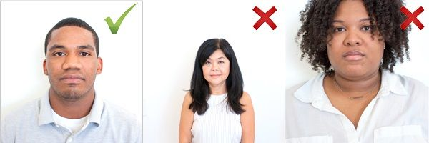
DEADLINES:
The deadline to submit a photo is five (5) business days before move in. If your photo is not received in time, you will need to visit the card office on campus once you arrive. This may delay your access to essential campus services and facilities including your residence hall, meal plan and dining bucks.

STEP 2 – PAWCARD E-ACCOUNTS PORTAL
Once you find the photo that you like, upload (1) your photo and (2) a photo of your driver's license or passport to the Profile tab via PAWCard eAccounts portal.

Please have the photo of your ID ready BEFORE starting the submit process so your browser does not time out. You will be required to resubmit the entire package if we do not receive both.

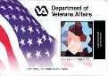
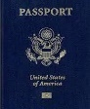
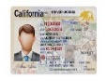


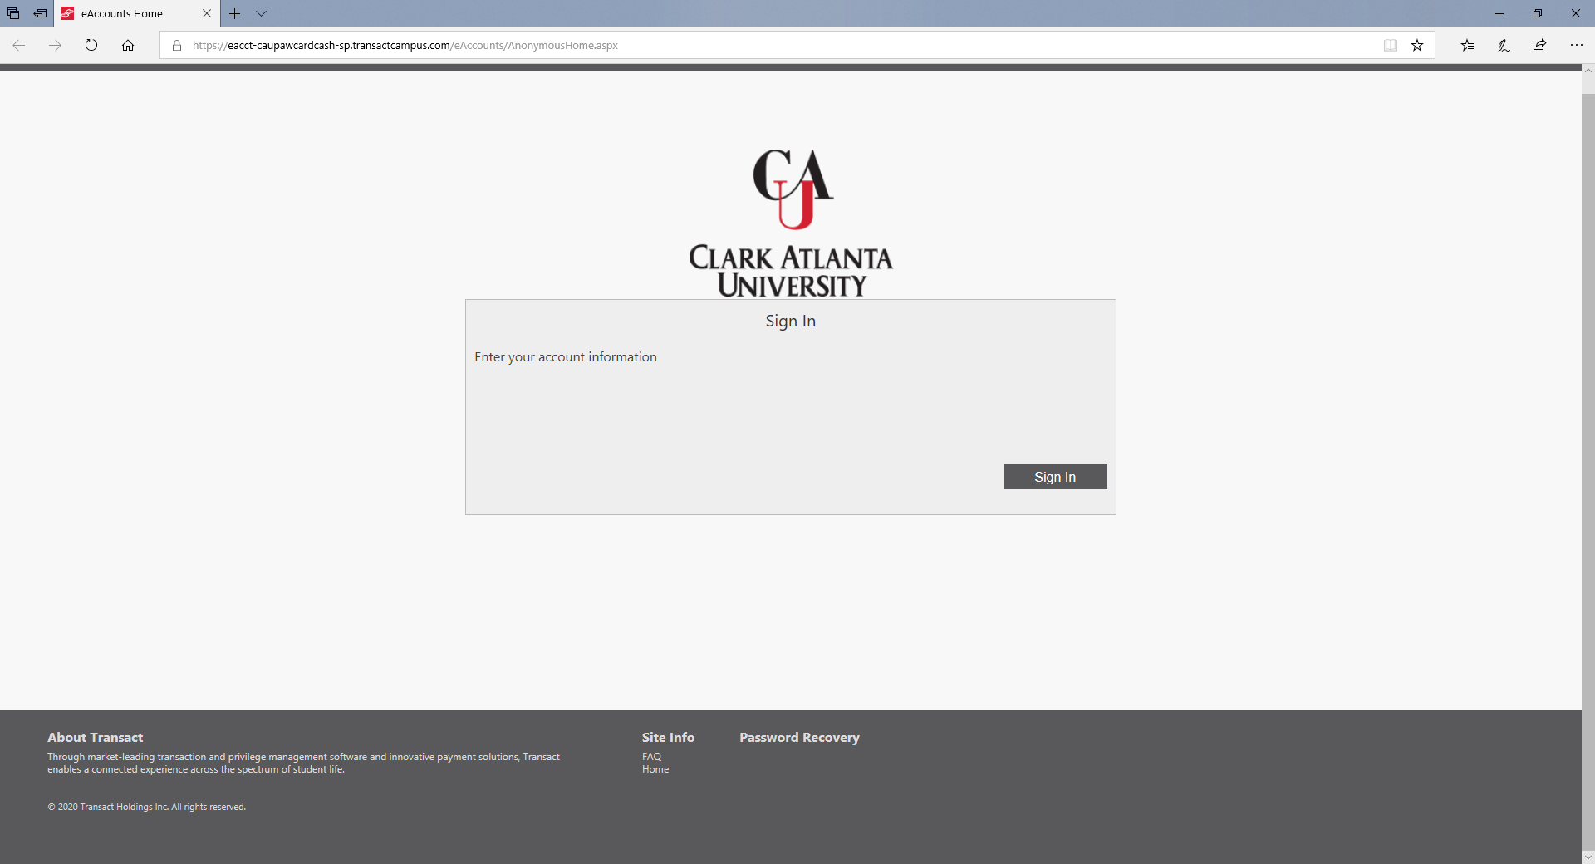
1. ®Sign In
(use CAU email address)
®Click on Profile

4. Submit your Govt.
Issued Photo ID
(e.g. Driver’s
License or Passport)
3. Submit and click
“Next” to proceed
2. Upload your photo
SUBMIT & SIGN OUT
Govt Issued Photo ID
SUBMIT

.jpg .png .gif
PAWCard Office is processing your photo
Take or upload your ID photo now

To get started, visit:
https://caupawcardcash-sp.transactcampus.com/eAccounts
Once your photo is submitted, the PAWCard Office will verify your information to ensure your security. You will receive an email when your identification photo is approved.

STEP 3 – CHECK YOUR E-MAIL

Please allow 3-5 business days for processing. You will receive an e-mail once the review process is complete. Follow any instructions in the e-mail, as necessary.
- If the photo is rejected, you will be required to submit a new photo.
- If the photo is approved, no further action is needed.

STEP 4 – RECEIVE YOUR PAWCARD
Look for instructions from your new student orientation program on when and where to pick-up your PAWCard.

If you have any questions, please call the PAWCard Office at
404-880-8729 or email us at CAUPAWCardContactUs@cau.edu

Frequently Asked Questions
Can I submit a different photo after one has been approved?
You will not be able to submit another photo once one has been approved.
Can I get another PAWCard with a new photo?
Your first PAWCard is complimentary. Replacement PAWCards with a new photo will cost $25.
What if my photo was not approved?
You will receive an email denying approval of your photo. You will be able to resubmit via a link in the denial email response.

